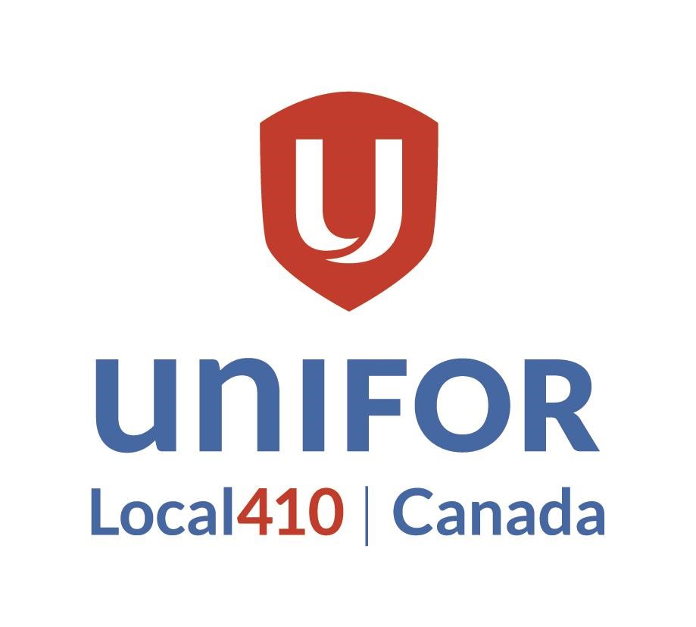

NOMINATION FORM
2023 Unifor Atlantic Regional Council

I, _________________________________hereby nominate
NAME OF NOMINATOR (PLEASE PRINT)

__________________________________ for the position of delegate to attend the
NAME OF NOMINEE (PLEASE PRINT)

2023 Unifor Atlantic Regional Council in Moncton, NB

______________________
Signature of Nominator

I hereby accept Nomination for the position of delegate to 2023 Unifor Atlantic Regional Council June 1-3:

______________________

Signature of Nominee

Forms may be emailed or sent via inter-company mail to the address below provided they are received by May 3:

Elections Committee
Unifor Local 410
21 Mews Place Suite 202
St. John's, NL A1B 4N2
mcompton@unifor410.ca

